## Name: Laura C. Larregui Date: January 6, 2020

## Lab 01 - The Relational Data Model

Part 1 – VidCast Database

1. Identify at least 4 challenges to fitting this data into the relational data model.

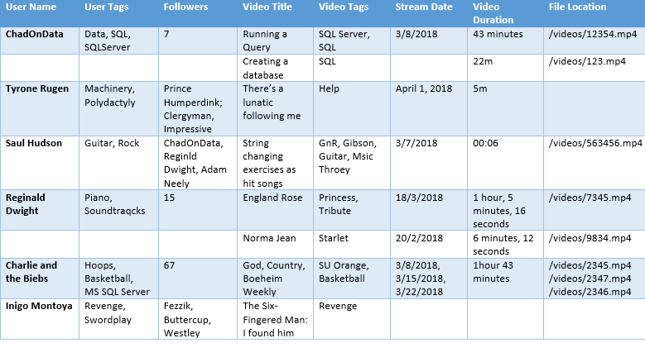

* The first issue I can identify from the table above is that not every record has a username. I believe each record should have a username to keep evidence of the authorship of each stream/video.
* There are quite some typos in the user tags attributes. Making sure the spelling is correct on the user tags is fundamental for other users to browse or search the tags.
* The followers attribute has some inconsistencies. Some records have the number of followers, and others have the usernames of the followers. Identifying the variable type (integer or character string) for this attribute is essential.
* The video tag attribute has the same issue as the user tags. There are some typos among the tags.
* The stream date attribute needs a consistent format. Moreover, there are some records that have no value or that have multiple values. For uniformity, stream date should be always record as the original date of publication.
* The video duration attribute needs a consistent format as well. While other records only have an abbreviation, the word ‘minutes’ is spelled out completely in certain records.
* For consistency, every video should always have only one file location.

Part 2 – Diagramming with Draw.IO

